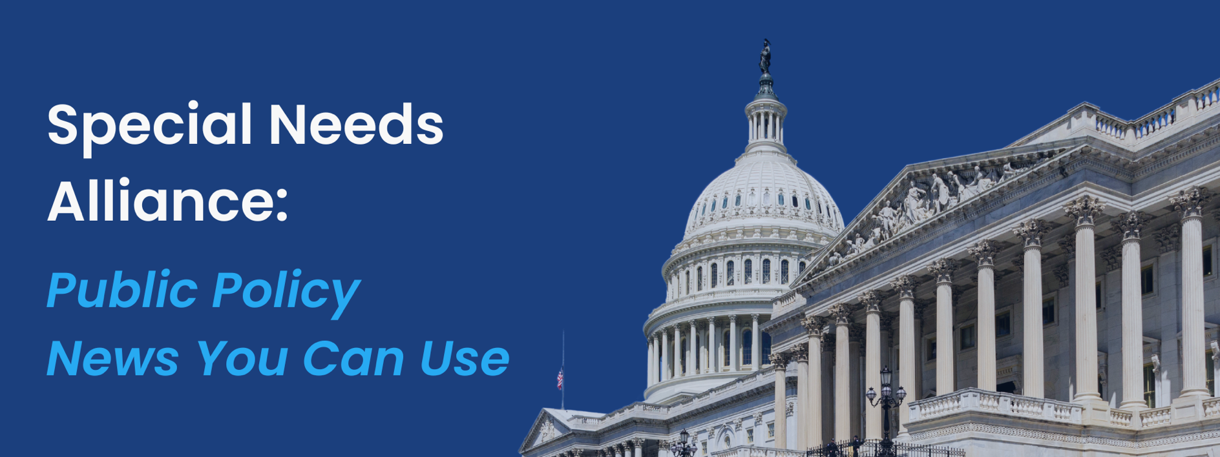
July 1, 2024
- NPR Investigation Finds Outdated “Marriage Penalty” for People with Disabilities Relying on Supplemental Security Income, Medicaid
Last week, National Public Radio released an investigative piece on Supplemental Security Income (SSI) and found that many people with disabilities get caught in a “marriage penalty” people with disabilities get kicked off the SSI program after getting married, since the threshold for SSI is disproportionately low for this population. This “marriage penalty” results from SSI’s limit on how much someone can own in savings and assets. The threshold for individuals is $2,000, while couples are limited to $3,000; both of those levels have not changed since 1989. If the SSI thresholds had kept up with inflation from the program’s inception, today’s individual limit would be more than $10,000 and the limit for couples would be closer to $17,000. In most states, people eligible for SSI are made eligible for Medicaid as well. Consequentially, these people caught in the “penalty” lose both SSI and Medicaid benefits, leading to some couples choosing to divorce or never marry to remain eligible for the stabilizing financial supports. Earlier this month, Social Security Commissioner Martin O’Malley called for raising the asset limit but bills to raise the limit have stalled.
- HHS Finalizes Rule to Penalize Providers That Have Committed Information Blocking
The U.S. Department of Health and Human Services (HHS) issued a final rule to penalize health care providers engaging in information blocking, as mandated by the 21st Century Cures Act (Cures Act). This rule introduces disincentives for providers found to obstruct the access, exchange, or use of electronic health information (EHI) without legal or regulatory justification. Under the Medicare Promoting Interoperability Program, hospitals and critical access hospitals committing information blocking will not qualify as meaningful EHR users and will face reduced payments. For the Merit-based Incentive Payment System (MIPS), clinicians committing information blocking will receive a zero score in the Promoting Interoperability category, affecting their overall MIPS score. Accountable Care Organizations (ACOs) and related providers committing information blocking may be barred from the Medicare Shared Savings Program for at least one year, losing significant potential revenue. These measures will be effective 30 days after publication, with additional disincentives possible through future rulemaking.
- CMS Announces Cost Savings for Prescription Drugs through Medicare Rebate Program
The Department of Health and Human Services (HHS), through the Centers for Medicare & Medicaid Services (CMS) announced that Medicare enrollees will pay less for 64 drugs available through Medicare Part B. The Part B drugs will have a lowered coinsurance rate for the quarter from July 1, 2024 through September 30, 2024 because each drug company raised prices faster than the rate of inflation. More than 750,000 Americans with Medicare use these drugs, which treat conditions including cancer and osteoporosis, every year. The Medicare Prescription Drug Inflation Rebate Program, a part of the Inflation Reduction Act, will allow some people with Medicare who use the drugs during this time period to save between $1 and $4,593 per day.
- U.S. Surgeon General Declares Firearm Violence a Public Health Crisis
U.S. Surgeon General Dr. Vivek Murthy issued a landmark Advisory on Firearm Violence, declaring it a public health crisis. This is the first advisory on this topic published by the Surgeon General’s Office, highlighting the devastating impacts of firearm violence on the American people. The advisory reveals that since 2020, firearms have been the leading cause of death among children and adolescents aged 1-19, surpassing cancer, motor vehicle deaths, and poisoning. It also reports that in 2022 alone, 48,204 individuals died from firearm-related injuries, including suicide, homicide, and unintentional deaths, marking an increase of over 8,000 lives lost since 2019. Additionally, the advisory includes a recent survey indicating that 54 percent of Americans report that either they or a family member have experienced a firearm-related incident. The Surgeon General’s Office has incorporated a public health approach to reducing firearm violence in the Advisory, emphasizing critical research investments, community risk reduction and education, and firearm risk reduction prevention strategies.
- HRSA Announces New Action to Improve Housing Accessibility for People with HIV
The Department of Health and Human Services (HHS), through the Health Resources and Services Administration (HRSA), announced new policy action to enhance housing access for people with HIV served by the Ryan White HIV/AIDS Program. This new guidance allows, for the first time, the use of program funds to cover housing security deposits for eligible clients, addressing a significant barrier highlighted by patients and advocates. Announced during the Advancing Housing, Health, and Social Care Partnerships Conference, this action supports the National HIV/AIDS Strategy and the Ending the HIV Epidemic initiative by helping individuals remain engaged in care. The Ryan White HIV/AIDS Program serves over 560,000 low-income individuals, focusing on high-need communities and addressing factors like housing that impact care engagement.
- House Appropriations Subcommittee Releases FY2025 Bill for Labor, Health and Human Services, Education, and Related Agencies, Cuts Spending by 11%
The House of Representatives Committee on Appropriations Subcommittee on Labor, Health and Human Services, Education, and Related Agencies held a markup for the FY2025 Labor, Health and Human Services, Education, and Related Agencies Act, which funds the operations of those agencies. The measure reflected the Republican majority through its budgetary restraint, amounting to 11% cuts when compared to FY2024. The subcommittee did not offer any amendments during the markup and, after tense opening remarks from leadership from both parties, passed the bill along strict party lines.

In addition to cuts in the Department of Labor and Department of Education, and related agencies, the Republican Bill for FY2025 includes major Health and Human Services (HHS) cuts. Cuts were also made to Health Resources and Services Administration (HRSA), the Centers for Disease Control and Prevention (CDC), and the National Institutes of Health (NIH). In addition, the bill includes $11.9 billion for the Social Security Administration’s (SSA) operating expenses, a decrease of $453 million below the 2024 level and $1.4 billion below the 2025 request. House Democrats are concerned this action would lead to the closures of Social Security field offices, extend wait times for retirement claims and customer service, and delay disability claims decisions.
- CBO and JCT Release Analysis on Permanently Extending ARPA’s Expanded Premium Tax Credit Structure
The Congressional Budget Office (CBO) and Joint Committee on Taxation (JCT) released a comprehensive analysis of the budgetary effects of making permanent the expanded premium tax credit structure that was provided in the American Rescue Plan Act of 2021 (ARPA) and later extended through 2025 in the 2022 reconciliation act. The ARPA reduced the maximum amount that eligible enrollees must contribute towards premiums for health insurance purchased through marketplaces established by the Affordable Care Act (ACA). The ARPA also extended eligibility to people who earn above 400 percent of the federal poverty level. The CBO and JCT estimate that maintaining the policy permanently would increase spending by $275 billion, decrease net revenues by $60 billion, and consequentially increase the budget deficit by $335 billion over the 2025-2034 period.
- Members of Congress Urge Greater AI Oversight from CMS in MA Coverage Decisions
Forty-five House Members and four Senators, led by Reps. Judy Chu (D-CA), Jerrold Nadler (D-NY), and Sen. Elizabeth Warren (D-MA), released a bipartisan, bicameral letter urging the Centers for Medicare and Medicaid Services (CMS) to increase oversight of artificial intelligence (AI) and software tools used to guide coverage decisions in Medicare Advantage (MA) plans. Multiple MA insurers currently use unregulated algorithms and AI tools to determine when to cut off payment for patient treatments, leaving seniors either to live without coverage or pay for their care themselves. Some of the actions that members of Congress encouraged CMS to take including to clarify the specific elements that must be contained in prior authorization denial notices, establish an approval process to review AI and algorithmic tools and their inputs to ensure the integrity of their use, and to prohibit the use of AI/algorithmic tools and software from use in coverage denials until a systematic review of their use can be completed.
- House Committee on Ways & Means Subcommittee on Health Holds Hearing on Value-Based Care
The House Committee on Ways & Means Subcommittee on Health held a hearing on Improving Value-Based Care for Patients and Providers. Subcommittee Chairman Vern Buchanan (R-FL) expressed support for movement away from the fee-for-service model towards value-based care and called upon the CMS Innovation Center (CMMI) to produce models that generate savings. Subcommittee Ranking Member Lloyd Doggett (D-TX) echoed the Chairman’s concerns and expressed worry over CMMI’s evaluation methods of models. Witnesses and Representatives explored a variety of value-based problems and solutions including improvements to the physician fee schedule, CMMI congressional oversight, and changing the metrics used to determine quality care. Healthsperien covered the hearing and detailed notes are available here.

What’s on Tap
- Last week, the U.S. Supreme Court overturned a landmark 1984 decision – Chevron v. Natural Resources Defense Council – that in relevant part established a standard of deference provided to federal agencies on the part of courts when the agencies assessed discrepancies or uncertainties in statute. The “Chevron Doctrine” has long been a backbone of power afforded to federal administrative agencies—particularly effective in justifying decisions made by agencies in the areas of environmental protections, public health, and other heavily technical fields. Because of the Court’s decision to overturn the Chevron Doctrine, the actions of federal agencies are far more likely to be subject to judicial review. This will have seismic consequences on the way that federal agencies – including the Department of Health and Human Services (HHS), the Centers for Medicare and Medicaid Services (CMS), the Food and Drug Administration (FDA), and other agencies. – approach sub-regulatory and regulatory guidance/actions. Chief Justice John Roberts, author of the majority opinion, maintained that the decision does not call into question prior cases that relied on the Chevron decision, but the new ruling will create pressures on actions taken by experts at federal agencies that did not rely on the decision and all actions moving forward. For example, long-term care providers believe that CMS’ nursing home staffing mandate and home and community-based service rule, in addition to the FTC’s non-compete rule and the Labor Department’s overtime eligibility rule, may all be vulnerable due to the end of the Chevron Doctrine.
- Last Wednesday, HHS, through CMS, announced that Medicare enrollees will pay less for 64 drugs available through Medicare Part B. The Part B drugs will have a lowered coinsurance rate for the quarter from July 1, 2024 through September 30, 2024 because each drug company raised prices faster than the rate of inflation. More than 750,000 Americans with Medicare use these drugs, which treat conditions including cancer and osteoporosis, every year. The Medicare Prescription Drug Inflation Rebate Program, a part of the Inflation Reduction Act, will allow some people with Medicare who use the drugs during this time period to save between $1 and $4,593 per day.
- Last Thursday, President Joe Biden and former President Donald Trump took center stage at the first presidential debate of the 2024 election. Several significant health care issues were discussed, including the cost of prescription drugs, veterans’ health care, the opioid crisis, and the future of Medicare. Biden emphasized efforts to reduce prescription drug costs, while Trump focused on expanding private health care options for veterans. On the opioid epidemic, Trump blamed rising drug deaths on the pandemic, while Biden emphasized the need for fentanyl-detecting machinery at the border. Both candidates discussed Medicare’s solvency and actions to lower insulin costs. On abortion, Trump supported state-level decision-making post-Roe v. Wade, while Biden backed Roe v. Wade’s protections. Debate also focused on both candidates’ approaches to the COVID-19 response.
- In the coming weeks, CMS is expected to release proposed rules that will outline payment and policy changes for 2025, including rules for hospital outpatient facilities, hospice facilities and skilled nursing facilities, and the physician fee schedule. The proposed rules will be finalized in the fall to ensure payment rates can be set by the end of the year.

Upcoming Events
Both chambers of Congress are out of session this week, no hearings or markups will take place.



